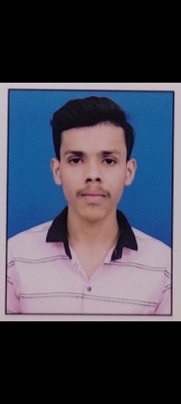

**Padam Singh**

Nand Nagri, B-Block, Delhi - 110093

Mobile no. 9310521020

[padam4030@gmail.com](mailto:padam4030@gmail.com)

**About Me**

*To get an opportunity where I can make the best of my potential and contribute to the organization’s growth.*

**Education**

|  |  |  |  |
| --- | --- | --- | --- |
| **Education** | **Year of Passing** | **Board/University** | **Percentage%** |
| S.S.C | March 2018 | C.B.S.E | 65.40% |
| H.S.C  (Commerce) | Feb 2020 | C.B.S.E | 65.66% |
| CHNM  (ITI PUSA) | 2022 | NCVT | 88.66% |
| Advance Diploma In  IT | 2022 | NCVT | Pursuing |

**Skills**

• CHNM (ITI PUSA) Completed in 2022

Marks 88.66%

• Good Command at English & Hindi

(Speaking &Typing)

**Work Experience**

Fresher

**Croficiency**

* MS Word
* Excel
* Power Point
* IT
* Computer Hardware

**Languages**

 Hindi English



**Personal Details**

|  |  |  |
| --- | --- | --- |
| Full Name: | Padam Singh |  |
| Father’s Name: | Mr. Raj Pal |  |
| Mother’s Name: | Mrs. Kamlesh |  |
| Birthday: | October 25th 2000 |  |
| Gender: | Male |  |
| Marital Status: | Single |  |
| Nationality: | Indian |  |
| Religion: | Hindu |  |
|  |  |  |
|  |  |  |

**Declaration**

I am Padam Singh hereby declare that the information contained herein is true and correct to the best of my knowledge and belief.

Place: Your truly

Date: Padam Singh